Schengen Visa Photo Guide
Print this and take it to the photo studio. Wrong photos are one of the most common reasons files get sent back.
Your photo must be
- Size 35 × 45 mm (passport size), face covering about 70–80% of the photo
- Taken within the last 6 months
- In colour, sharp and good quality, printed on photo paper
- Plain white or light background — no shadows, no patterns
- Full face from the front, showing the whole head and top of the shoulders
- Neutral expression, mouth closed, eyes open and clearly visible
- Same photo you upload in the online form (if your country uses one)
Glasses and head covering
- Glasses are allowed only if the eyes are clearly visible and there is no glare on the lenses. Safest option: remove them.
- Head covering is allowed only for religious reasons, and the full face — forehead to chin — must be visible with no shadow.
- No caps, sunglasses, headphones or hair covering the face.
Examples
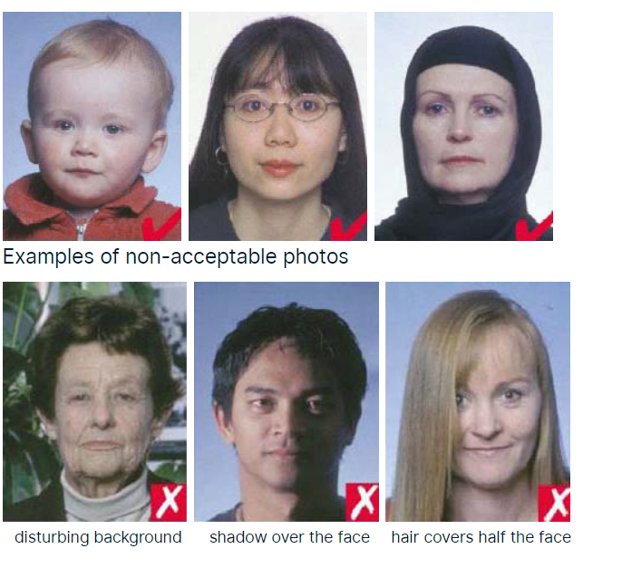
Top row: acceptable. Bottom row: rejected (busy background, shadow on face, hair over face).
Quick tip
Most photo studios in Dubai know the "Schengen size". Ask for 4 prints — keep 2 spare for other applications.

